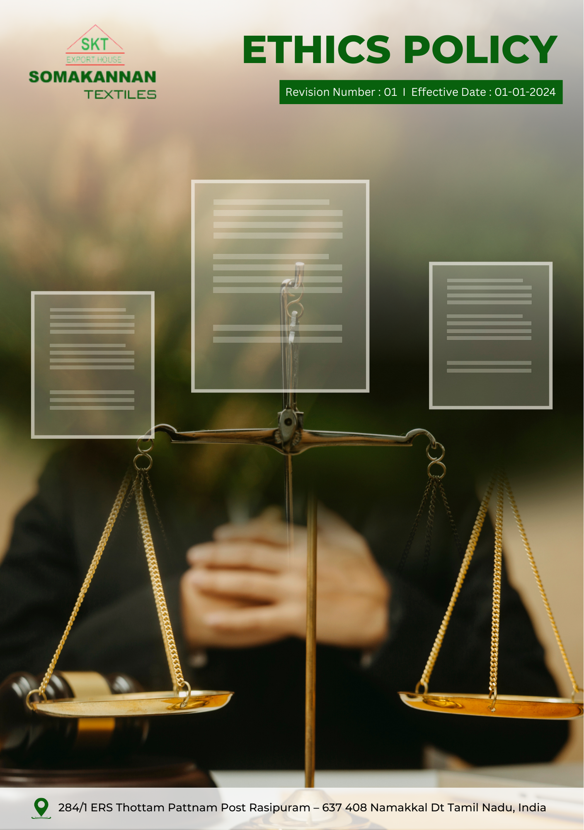
Revision Number : 03 | Last Review Date : 01-01-2026

Index

❖ Introduction 3
❖ Scope 3
❖ Key Focus Areas 3
❖ Qualitative Objectives 4
❖ Quantitative Targets 4
❖ Roles and Responsibilities 5
❖ Examples and Guidance 6
❖ Handling Policy Violations and Disciplinary measures 7
❖ Action Framework 8
❖ Training and Rehabilitation Programs 8
❖ Monitoring and Reporting 9
❖ Communication and Transparency 9
❖ Continuous Improvement 9
❖ SDGs (Sustainable Development Goals) Covered in the Ethics Policy 10
❖ Review Mechanism 10
❖ Revision History 11
❖ Employee Acknowledgment: Ethics Policy 12

Introduction
At Somakannan Textiles, we are committed to conducting our business with the highest standards of ethics, transparency, and integrity. As a reputable manufacturer and exporter of quality cotton home textiles, we recognize that responsible business conduct and ethical decision-making are essential to sustaining long-term relationships with employees, customers, suppliers, and communities. This Ethics Policy outlines our dedication to honest and fair practices, compliance with applicable laws and regulations, and the prevention of unethical behavior across all aspects of our operations. We expect all employees, contractors, and business partners to uphold the principles set forth in this policy, ensuring that Somakannan Textiles operates with accountability, respect, and trust in every engagement.

Scope
This policy applies to all employees, contractors, suppliers, partners, and stakeholders associated with Somakannan textiles, across all locations worldwide. It encompasses all our operational sites and extends to interactions with clients, suppliers, regulators, and the wider community.

Somakannan Textiles | 284/1 ERS Thottam Pattnam Post Rasipuram – 637 408 Namakkal Dt Tamil Nadu India.

Key Focus Areas
- Corruption: Strictly prohibit bribery, kickbacks, and any form of corrupt practices through clear policies, training, and enforcement.
- Conflict of Interest: Require disclosure and proper handling of personal or professional interests that may influence company decisions.
- Fraud: Prevent and detect fraud through internal controls, regular audits, and secure reporting mechanisms.
- Anti-Money Laundering: Comply with AML laws by verifying transactions, monitoring for suspicious activity, and training employees on red flags.
- Information Security: Safeguard sensitive data through robust cybersecurity measures, access controls, and regular employee awareness programs.

Qualitative Objectives
- Corruption:
- Carry out due diligence specific to anti-bribery and corruption when evaluating mergers and acquisitions and joint ventures.
- Maintain a zero-tolerance policy for bribery and corruption and ensure strict compliance with anti-corruption laws and company policies.
- Promote a culture of integrity where employees understand the importance of rejecting bribery and unethical practices.

- Conflict of Interest:
- Promote a culture of transparency, encouraging employees to avoid situations where personal interests could conflict with business interests.
- Maintain transparency in dealings with suppliers, clients, and partners by documenting and managing conflicts appropriately.

- Fraud:
- Strengthen organizational trust by establishing a zero-tolerance approach to fraudulent behavior.
- Encourage vigilance and accountability among employees in detecting unusual or suspicious activities.

- Anti-Money Laundering (AML)
- Promote awareness of AML responsibilities among employees, emphasizing vigilance in transactions.
- Ensure adherence to legal and regulatory requirements to prevent misuse of company operations for illegal purposes.

- Information Security:
- Enforce and maintain stringent information security protocols to protect sensitive business, employee, and client data from unauthorized access, breaches, and cyber threats.
- Ensure continuous improvement of security measures in line with emerging threats and regulatory requirements.

Quantitative Targets
2023 is established as the baseline year for monitoring our ethical compliance and performance, with targets set to be achieved by 2030.

- Corruption:
- Ensure inclusion and compliance of anti-bribery clauses into 100% of supplier and partner contracts by year 2030.
- Train 100% of procurement and finance teams on anti-corruption policies annually.
- Maintain zero instances of corruption reported in annual audits.

- Conflict of Interest:
- Conduct annual conflict-of-interest declarations for 100% of managerial and supervisory employees till 2030.
- Review and resolve 100% of disclosed conflict-of-interest cases within 30 days of identification.
- Maintain zero unresolved conflict-of-interest cases annually.
- Fraud:
- To maintain the implementation of a fraud detection mechanism to monitor and flag suspicious activities, and hence achieve 0% of undetected fraudulent transactions till year 2030.
- Conduct fraud risk assessments across all functions annually.
- Maintain zero fraud - related incidents annually.
- Anti-Money Laundering:
- Provide annual AML awareness training to 100% of relevant employees
- Implement and maintain transaction monitoring and reporting procedures to ensure 100% of identified suspicious activities are reviewed and addressed in line with legal requirements by 2030.
- Ensure due diligence for 100% high-value financial transactions and business partners

- Information Security:
- Achieve 100% implementation of role-based access controls for systems handling sensitive or confidential information by 2030.
- Achieve 90% of third-party vendors comply with company’s information security standards and annual risk assessments by 2030.

Roles and Responsibilities
- Senior Management:
- Oversee corruption prevention, conflict-of-interest management, fraud prevention, AML compliance, and ensure timely review and resolution of reported ethical concerns.
- Ethics and Compliance Officer:
- Responsible for overseeing the implementation of Somakannan’s Ethics Policy, ensuring adherence to anti-corruption, anti-fraud, and anti-money laundering regulations, and managing any conflicts of interest that arise.
- Finance & Internal Audit Team:
- Monitor financial controls and fraud risks, conduct periodic internal audits, ensure compliance with AML requirements, review financial transactions and contracts, and support investigations and corrective actions related to ethical breaches.
- Human Resources (HR)
- Coordinate ethics, compliance, and awareness training programs; manage conflict-of-interest declarations; support grievance handling mechanisms; and integrate ethical standards into recruitment, performance management, and employee conduct processes.
- Information Security Manager:
- Implement and maintain information security controls, conduct regular cybersecurity and data protection risk assessments, manage secure data handling practices, and deliver information security awareness and training programs.
- Employees:
- Every employee is accountable for upholding ethical standards, reporting any violations, and participating in regular ethics and compliance training programs.

Examples and Guidance
To support consistent understanding and implementation of this Ethical Conduct Policy, the following examples and guidance provide practical interpretations of expectations and actions:
- Preventing Corruption
- Example: A supplier offers a production manager free tickets to a sports event in exchange for prioritizing their order.
- Guidance: The manager must decline the offer and report it to the compliance officer. Accepting gifts or favors that could influence business decisions violates company policy. All supplier interactions must remain transparent and objective.

- Conflict of Interest
- Example: A quality control supervisor is asked to approve materials supplied by a company owned by a family member.
- Guidance: The supervisor must disclose the relationship and refrain from decision-making. Any potential conflict of interest should be reported to management, ensuring decisions are made without personal bias.

- Fraud
- Example: A procurement clerk notices a supplier submitting duplicate invoices for raw material deliveries.
- Guidance: The clerk must flag and escalate the issue immediately. All employees are responsible for reporting suspicious financial activity and ensuring proper verification of transactions.

- Anti-Money Laundering (AML)
- Example: A customer requests to split a large yarn order into multiple smaller payments to avoid regulatory reporting.
- Guidance: This is a potential AML concern. The transaction must be reported for review according to company AML procedures. Employees must remain vigilant and follow established reporting protocols.

- Information Security
- Example: An employee leaves confidential production plans or client orders on a shared factory desk.
- Guidance: The incident must be reported to the IT and compliance teams immediately. Sensitive documents must be securely stored and disposed of. Employees are expected to follow data protection and confidentiality protocols at all times.

Handling Policy Violations and Disciplinary measures
Somakannan Textiles maintains a zero-tolerance approach toward violations of its Ethics Policy. All suspected or confirmed breaches are taken seriously, investigated impartially, and addressed promptly to uphold integrity, accountability, and responsible business conduct.
- Reporting Violations: Employees, contractors, and business partners are encouraged to report any unethical, illegal, or suspicious behaviour through direct supervisors, the internal compliance team, or the confidential whistleblower system. Reports can be submitted anonymously without fear of retaliation.
- Investigation Process: All reported concerns are investigated promptly by designated personnel or independent experts, ensuring fairness, confidentiality, and protection of whistleblower identity unless legal disclosure is required.
- Disciplinary Actions: Actions are applied proportionally based on the nature, severity, and impact of the violation:
- Verbal or Written Warning: For minor or first-time breaches, outlining corrective measures to prevent recurrence.
- Suspension or Corrective Measures: For repeated or more serious breaches, including temporary suspension, retraining, or enhanced supervision.
- Termination of Employment or Contracts: For serious violations such as fraud, bribery, corruption, or deliberate conflicts of interest that compromise the company’s integrity.
- Legal Action: For illegal activities, including fraud, money laundering, or corruption, legal proceedings may be initiated, including reporting to law enforcement.
- Restitution and Financial Recovery: In cases of financial loss or misconduct, the company may seek recovery of losses, impose penalties, or pursue contractual remedies against responsible parties.
- Protection from Retaliation: Retaliation against whistleblowers or those cooperating in investigations is strictly prohibited. Any individual engaging in retaliatory actions will face disciplinary consequences.

Action Framework
- Reporting Mechanisms: Provide clear channels for employees, contractors, and partners to report ethical or compliance concerns, including a confidential whistleblower system.
- Investigation & Verification: Conduct impartial and confidential investigations to assess reported violations and gather evidence.
- Corrective Actions: Implement proportionate measures ranging from warnings and retraining to termination and legal action, based on severity.
- Prevention & Awareness: Strengthen policies, provide training, and communicate lessons learned to prevent recurrence.
- Monitoring & Accountability: Track corrective actions, review outcomes, and ensure adherence to ethical standards across the organization.

Training and Rehabilitation Programs
- For certain offenses, employees may be required to undergo additional ethics training or participate in rehabilitation programs to ensure a clear understanding of the company’s ethical standards and prevent future violations. This may accompany other disciplinary actions, such as warnings or suspensions.
- Somakannan implements disciplinary measures to address unethical behavior, prevent future violations, and foster a culture of accountability and integrity across the organization.

Monitoring and Reporting
- Ethics Hotline: Somakannan Textiles has established a confidential reporting channel for all employees, suppliers, and stakeholders to raise concerns related to unethical behavior, including corruption, fraud, or conflicts of interest. This system ensures issues are reported safely and without fear of retaliation, promoting transparency and ethical conduct throughout the organization.
- Internal and External Audits: Somakannan Textiles conducts regular internal and external audits to ensure adherence to applicable laws, industry standards, and internal policies. These audits cover areas such as anti-corruption, fraud prevention, anti-money laundering (AML), and ISO-certified quality management practices. By systematically reviewing operations, these audits strengthen integrity in both manufacturing and export processes and promote continuous improvement in compliance and governance.
- Incident Reporting: All reported incidents related to corruption, ethical breaches, or non-compliance are promptly documented and investigated by qualified personnel. Appropriate corrective actions are taken to address root causes, prevent recurrence, and uphold the company’s ethical standards and reputation in both domestic and global markets.

Communication and Transparency
- Public Access to Ethics Policy: Somakannan’s Ethics Policy is made publicly available to employees, suppliers, and stakeholders, ensuring transparency and awareness. The policy is regularly communicated through internal newsletters, meetings, and official updates to ensure understanding and adherence.
- Encouraging Open Dialogue: Employees are encouraged to discuss ethical concerns openly and report issues confidentially via dedicated channels, with the option to remain anonymous. This approach fosters a safe environment for raising concerns and promotes ethical decision-making throughout the organization.

Continuous Improvement
Somakannan Textiles is committed to continuously enhancing its ethical and operational practices. Policies are regularly reviewed and updated to align with evolving legal, social, and industry standards. The company proactively evaluates the effectiveness of its ethics framework, addresses emerging risks, and integrates lessons learned into business processes. Upholding high ethical standards remains central to Somakannan Textiles’ values and is key to maintaining trust with employees, partners, and global customers.

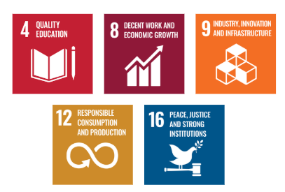
SDGs (Sustainable Development Goals) Covered in the Ethics Policy

Review Mechanism
The Ethics Policy will be reviewed annually by the Ethics and Compliance Officer in collaboration with the Internal Audit Team to ensure its ongoing effectiveness and relevance. This review will consider regulatory changes, stakeholder feedback, and the company’s evolving objectives. Any updates or revisions will be communicated to all employees and stakeholders. Progress toward the policy’s goals will be monitored, and necessary adjustments will be made to ensure continued alignment with Somakannan Textiles’ ethical standards.

Last Review Date: 01-01-2026
Next Review Date: 01-01-2027

Approved By:

Designation:

Revision History

Revision No. | Date | Description of Change / Updates | Approved by
1.0 | 01-01-2024 | Initial release of the document
2.0 | 01-01-2025 | Updated objectives and targets
3.0 | 01-01-2026 | Revised policy sections and formatting

Employee Acknowledgment: Ethics Policy
I acknowledge that I have received, read, and understood the Ethics Policy of Somakannan Textiles. I am aware of the company’s commitment to upholding ethical principles, including the prevention of corruption, fraud, and conflicts of interest, as well as compliance with anti-money laundering (AML) and antitrust regulations.
I understand my responsibility to uphold these ethical standards and agree to adhere to them in all business activities. I commit to reporting any potential violations of this policy through the appropriate reporting channels. I acknowledge that compliance with this policy is a condition of my continued employment or partnership with Somakannan.

Employee Name:

Employee Signature:

Date:

